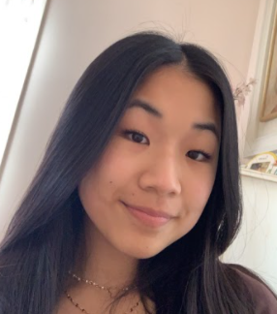
Name: Elaine Bai
Year in Course: 1st, Sophomore Year
Topic: Dermatology
Mentor: Dr. Pawelek, Yale University
Title: Function of PARP1 in DNA Repair
Bio:

Elaine is a sophomore in the science research course. She has been interested in topics in the medical field since early in her life, and has decided to translate that into her research study. The questions is what is the function of PARP1​, how it's involved with DNA repair​ and comparing its molecular activation of damaged DNA to roles of other PARPs​. As of now, she is trying to get into contact with mentors from different colleges to help assist with her research and was able to talk with two researchers at Yale University. Joining this class and accomplishing what she has of her study so far are things she is very proud of.
In her spare time, she devotes her time to multiple clubs, mainly dancing, winning multiple awards while also being involved in the Nutcracker for 5 years. She has been dancing for 12 years at Pinewood School of Dance, competed with their competition team and completed levels 1 to 10 in performance awards and as well as winning scholarships to AAB Summer Intensive four years in a row. She has been working very hard this school year, having committed to both this class and one AP class and is excited to display the work she has done and present her research!

